**Extended Response 2**

**Haemostasis**

This task is an extended response that addresses the topic of haemostasis (blood clotting). This type of answer needs to be reasonably detailed and informative on the topic and can be written in many forms such as:

* Diagrams with detailed notes explaining the diagram
* Tables outlining the appropriate detail – in sentence form
* A series of dot points that are fully explained/described in relation to the topic
* Essays written in a similar way to an English essay
* A report with headings, sub-headings,…and explanations/descriptions within

Blood clotting involves a complex series of events and reactions that occur in sequence. Describe the steps involved in the process of **haemostasis** (blood clotting) from the initial damage to tissue right through to **clot dissolution**.

In your description you will need to include:

* the types of cells involved
* the names and functions of the chemicals involved
  + thrombin, prothrombin, fibrin, fibrinogen, plasmin, plasminogen, serotonin etc.
* blood vessel responses
* clotting factors

Full marks will not be achieved if steps and/or chemicals are missing and/or out of sequence.

You must also reference (using in-text style referencing) the entire paper and include a bibliography.

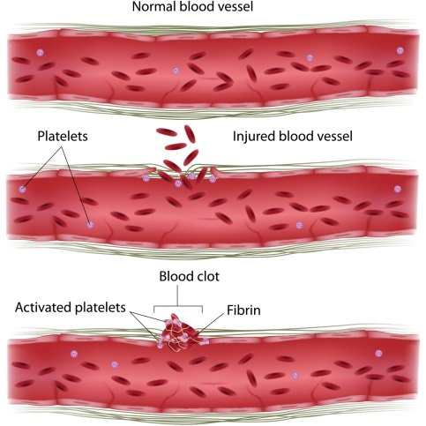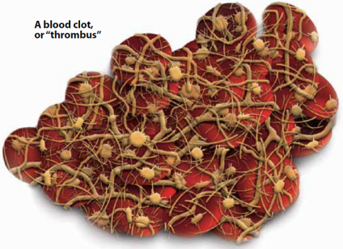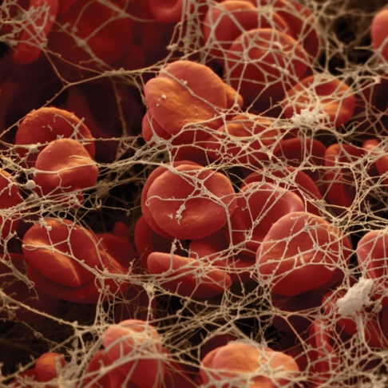This assignment is worth 10% of your Semester 1 mark.

**Guidelines**

There are 20 marks available for this assessment.

Introduction:

* Outline the reason and need for blood clotting **1 Mark**

Main Body:

* Events to be in sequence and covered in detail.
* Include from injury of tissue.
* Include each response and include names of any chemicals involved.
* Must mention:
  + Thrombocytes
  + Serotonin
  + Prothrombin
  + Fibrinogen **12 Marks**

Conclusion:

* Clot dissolution **3 Marks**

Referencing:

* In-text referencing of sources of all information **2 Marks**

Bibliography:

* Correctly constructed, alphabetical **2 Marks**

**Total 20 Marks**